P5.js Assignment 2 - Collector Card2

Red Hot Tips!

* Do you know about textAlign()?
* Do not forget about imageMode()!
* Do not forget about tint() if you want to overlap some images
* noStroke() and noFill() can also be useful

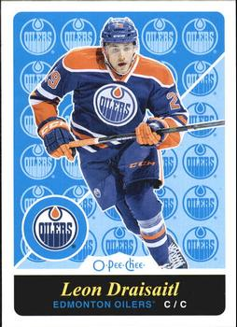 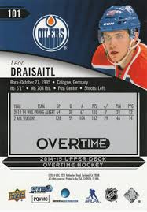

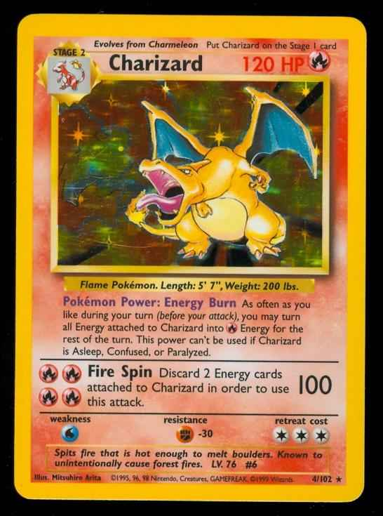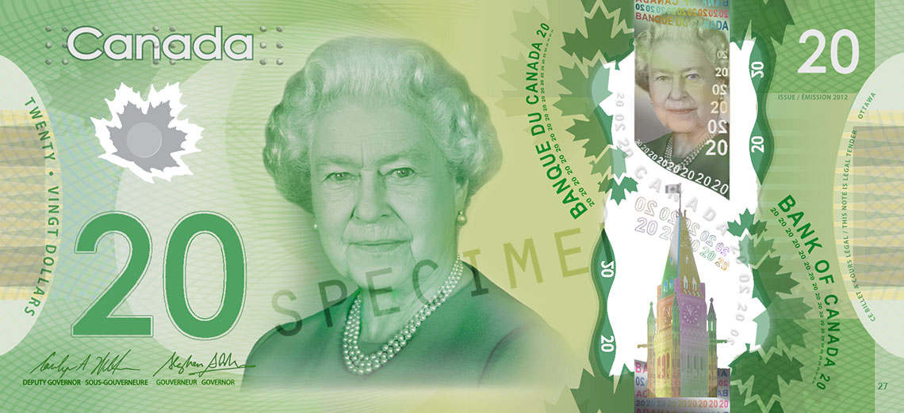

Your job is to create a:

* Sports card - or a sports style card using actors, your favourite band/singer, etc.
* Game card
* ID Card
* A $20 bill for Couplandia

Set Up

* Create a new P5.js file and name the file Assign2CollectorCard
* If doing a traditional collector card, set your canvas size to: 400,600. For other cards or topics, you can choose your own dimensions.

Base Requirements 50% - Your card must include the following:

* A variable to store the name of your person/character. Every time you print that name, you must use the variable, rather than hard coding in the text. In other words, your text line should look like *text(namevariable, 50, 50)* rather than *text(“Nugent-Hopkins”, 50,50)*
* a background colour
* a rectangle to indicate the shape of the card - Use the ROUNDED corner rectangle for a more professional look. [Click here](https://p5js.org/reference/#/p5/rect) to learn about rounded rectangles
* THREE pictures
  + a picture of the person/character
  + Other things such as a team logo, super-power indicator, etc.
* Two fonts plus at least 2 different sizes. Text ideas could include:
  + person’s name
  + facts or statistics
  + your company logo

Layout and Design 20%

| 5  Shows very little attention to alignments, sizes, etc. | 10  Demonstrates some attention to alignments, sizing, etc. | 15  Makes a solid effort to make the product look good. | 20  Layout is almost perfect. Things are centered where appropriate, spacing is consistent, etc. |
| --- | --- | --- | --- |

Final 30% - To get top marks, you must include

* at least 4 different pictures
* TWO fonts are used with at least 4 changes in size.
* Additional Shapes or lines to further enhance the look of your card

Extra Challenge (not for marks)

Add a mousePressed function that shows the BACK of the card while you are ***holding*** the mouse button.

Need Help?

For Text - Link to the following tutorial and then scroll down to the section called Displaying Text.

<http://processing.org/tutorials/text/>

For Adding Pictures - <http://processing.org/tutorials/pixels/>. or follow these instructions:

1. Save a picture with a simple name.
2. In Processing, choose Sketch… Add File and go find that picture you just saved
3. Set up the picture with these two lines:
   * PImage bikeImg;
   * bikeImg = loadImage("bike.jpg");
4. You can now add that image as many times as you want using one of the following lines of code
   * image(bikeImg, x ,y, width_you_want, height_you_want);
   * OR image(bikeImg, 25,100); This will just use the picture’s normal width and height.